**ASSIGNMENT NO.1.**

**Aim :-** To create ADT that implement the "set" concept.

a. Add (newElement) -Place a value into the set

b. Remove (element)

c. Contains (element) Return true if element is in collection

d. Size () Return number of values in collection

e. Intersection of two sets

f. Union of two sets

g. Difference between two sets h.Subset .

**Program Code:-**

#include <iostream>

using namespace std;

const int MAX=50;

template<class T>

class SET

{

T data[MAX];

int n;

public:

SET()

{

n=-1;

}

bool insert(T);

bool remove(T);

bool contains(T);

int size();

void print();

void input(int num);

SET unionS(SET,SET);

SET intersection(SET,SET);

SET difference(SET,SET);

};

template<class T>

void SET<T>::input(int num)

{

T element;

for(int i=0;i<num;i++)

{

cout<<"\nEnter Element: "<<i+1;

cin>>element;

insert(element);

}

}

template<class T>

void SET<T>::print()

{

for(int i=0;i<=n;i++)

cout<<" "<<data[i];

}

template<class T>

SET<T> SET<T>::unionS(SET<T> s1,SET<T> s2)

{

SET<T> s3;

int flag=0;

int i=0;

for(i=0;i<=s1.n;i++)

{

s3.insert(s1.data[i]);

}

for(int j=0;j<=s2.n;j++)

{

flag=0;

for(i=0;i<=s1.n;i++)

{

if(s1.data[i]==s2.data[j])

{

flag=1;

break;

}

}

if(flag==0)

{

s3.insert(s2.data[j]);

}

}

return s3;

}

template<class T>

SET<T> SET<T>::difference(SET<T> s1,SET<T> s2)

{

SET<T> s3;

int flag=1;

for(int i=0;i<=s1.n;i++)

{

for(int j=0;j<=s2.n;j++)

{

if(s1.data[i]==s2.data[j])

{

flag=0;

break;

}

else flag=1;

}

if(flag==1)

{

s3.insert(s1.data[i]);

}

}

return s3;

}

template<class T>

SET<T> SET<T>::intersection(SET<T> s1,SET<T> s2)

{

SET<T> s3;

for(int i=0;i<=s1.n;i++)

{

for(int j=0;j<=s2.n;j++)

{

if(s1.data[i]==s2.data[j])

{

s3.insert(s1.data[i]);

break;

}

}

}

return s3;

}

template<class T>

bool SET<T>::insert(T element)

{

if(n>=MAX)

{

cout<<"\nOverflow.SET is full.\n";

return false;

}

data[++n]=element;

return true;

}

template<class T>

bool SET<T>::remove(T element)

{

if(n==-1)

{

cout<<"Underflow. Cannot perform delete operation on empty SET.";

return false;

}

for(int i=0;i<=n;i++)

{

if(data[i]==element)

{

for(int j=i;i<=n;j++)

{

data[j]=data[j+1];

}

return true;

}

}

//data[n--]=0;

return false;

}

template<class T>

bool SET<T>::contains(T element)

{

for(int i=0;i<=n;i++)

{

if(data[i]==element)

return true;

}

return false;

}

template<class T>

int SET<T>::size()

{

return n+1;

}

int main() {

SET<int> s1,s2,s3;

int choice;

int element;

cout<<"\nEnter number of elements in SET1:";

cin>>element;//element is used for taking size

s1.input(element);

cout<<"\nEnter number of elements in SET2:";

cin>>element;//element is used for taking size

s2.input(element);

do

{

cout<<"\n***** SET OPERATIONS *****"

<<"\n1.Insert"

<<"\n2.Remove"

<<"\n3.Search"

<<"\n4.Size of Set"

<<"\n5.Intersection"

<<"\n6.Union"

<<"\n7.Difference"

<<"\n8.Check if Subset"

<<"\nEnter Your Choice: ";

cin>>choice;

switch(choice)

{

case 1:

cout<<"\nEnter Element: ";

cin>>element;

if(s1.insert(element))

{

cout<<element<<" inserted";

}

else

{

cout<<"Insertion Failed";

}

break;

case 2:

cout<<"\nEnter Element: ";

cin>>element;

if(s1.remove(element))

{

cout<<element<<" deleted";

}

else

{

cout<<"Deletion Failed";

}

break;

case 3:

cout<<"\nEnter Element: ";

cin>>element;

if(s1.contains(element))

{

cout<<element<<" is present";

}

else

{

cout<<element<<"is not Present";

}

break;

case 4:

cout<<"\nSize = "<<s1.size();

break;

case 5:

s3=s1.intersection(s1,s2);

cout<<"\nSET 1's elements: ";

s1.print();

cout<<"\nSET 2's elements: ";

s2.print();

cout<<"\nIntersection: :";

s3.print();

break;

case 6:

s3=s1.unionS(s1,s2);

cout<<"\nSET 1's elements: ";

s1.print();

cout<<"\nSET 2's elements: ";

s2.print();

cout<<"\nUnion :";

s3.print();

break;

case 7:

s3=s1.difference(s1,s2);

cout<<"\nSET 1's elements: ";

s1.print();

cout<<"\nSET 2's elements: ";

s2.print();

cout<<"\nDifference :";

s3.print();

break;

}

}while(choice!=0);

return 0;

}

**Output Screenshots:-**

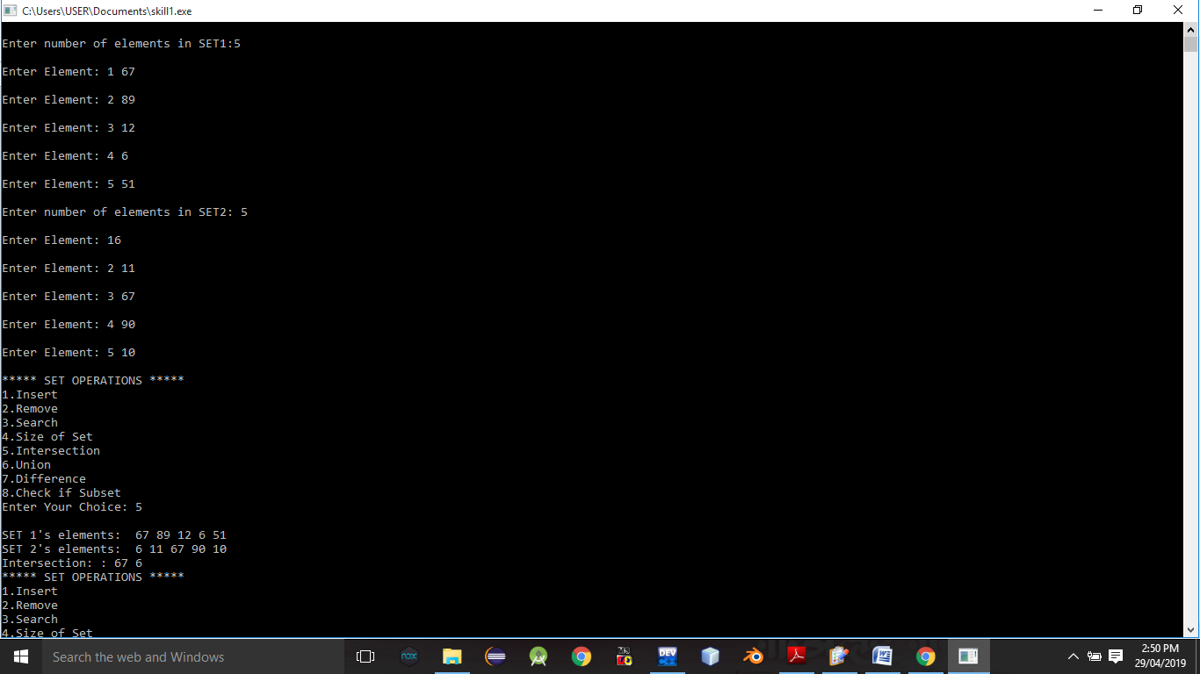

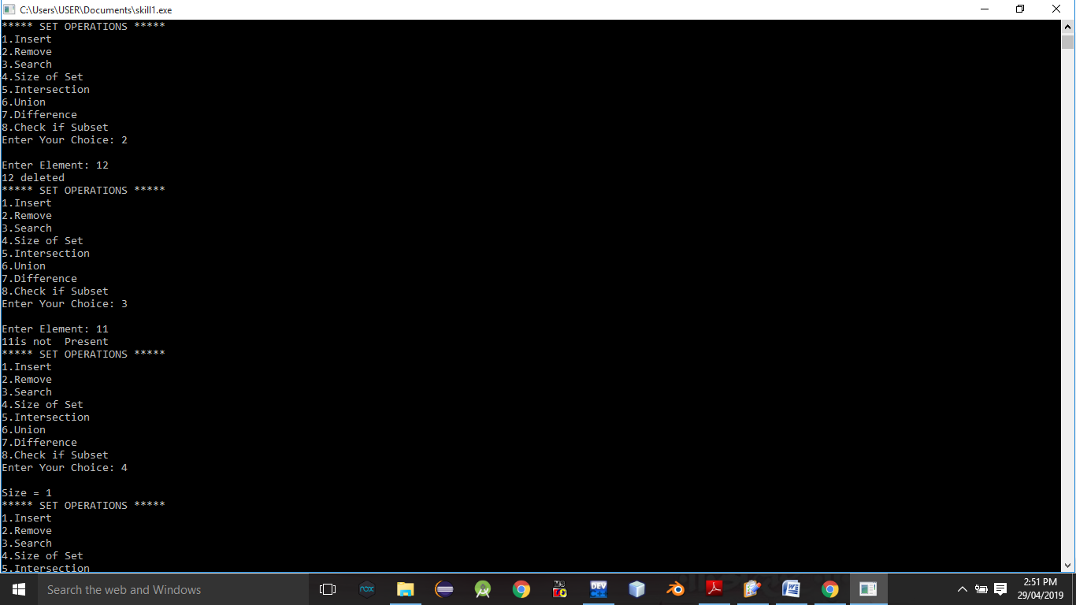

**Conclusion:-** Thus,we have studied different operations on set ADT.